Name: Oneeka Kundu Roll.No.:129 ExamRoll:11600223145 Date:8/1/26
Assignment No.: 1
Problem Statement: Create an account in AWS and configure a Budget
Solution:
PART 1: Create an AWS Account
Step 1: Go to AWS
Step 2: Sign Up
Step 3: Contact Information
Step 4: Payment Details
Step 5: Identity Verification
Step 6: Select Free plan -> Account created.
PART 2: Configure AWS Budget
Step 1: Open Billing and Cost Management -> Go to Budget and Planning -> Budgets
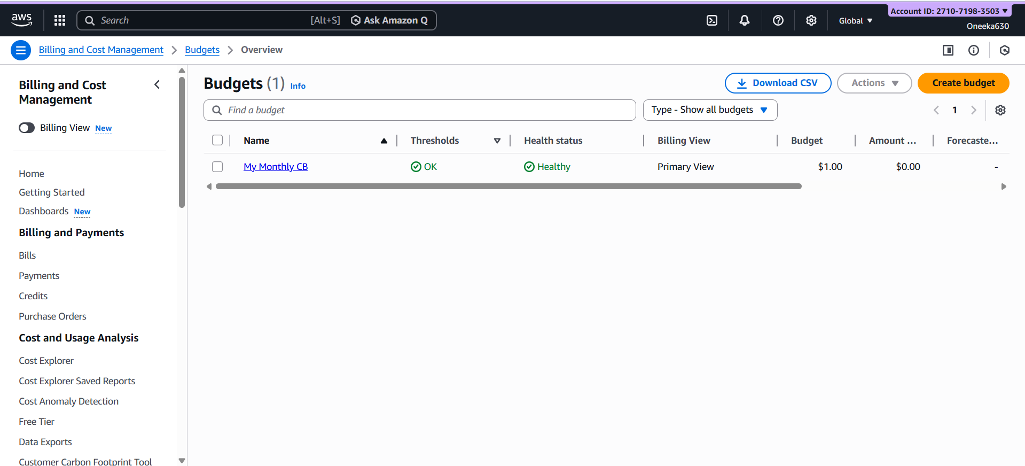
Step 2: Click Create budget -> Monthly cost budget.
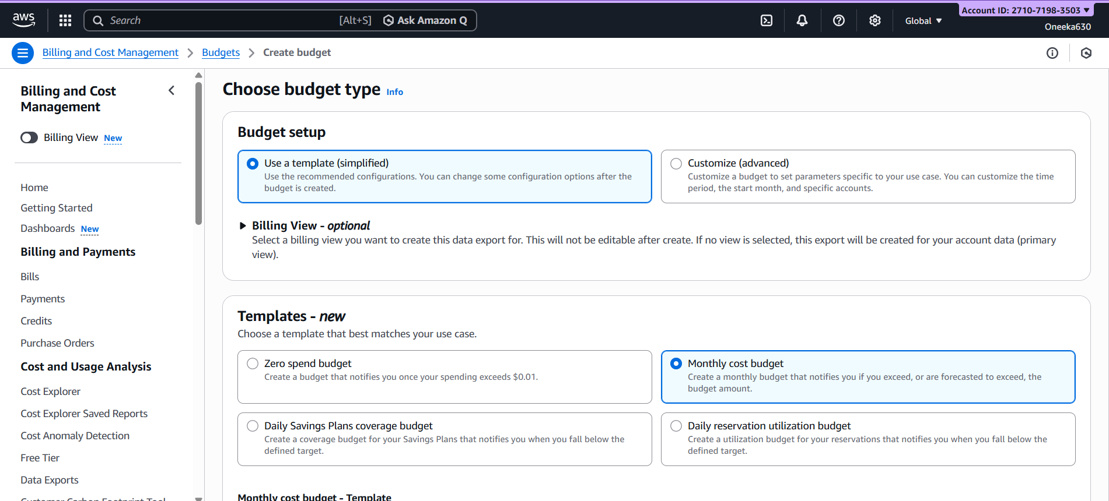
Step 3: Define Budget Details(Budget Name, Budget Amount, Email recipients)->Create Budget
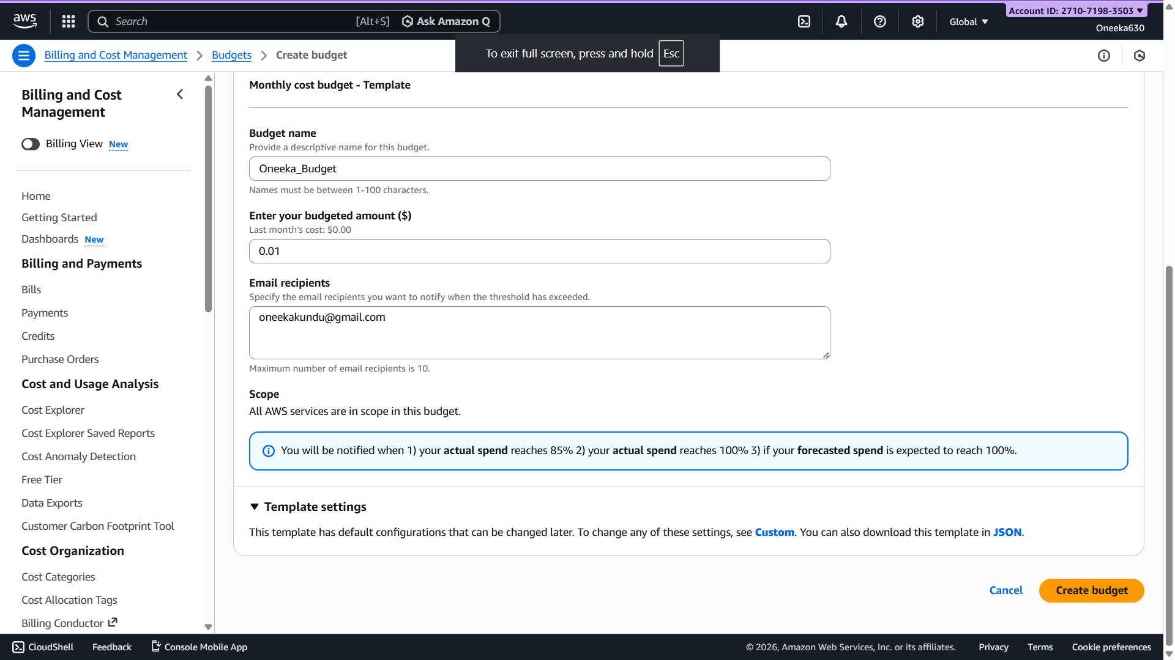

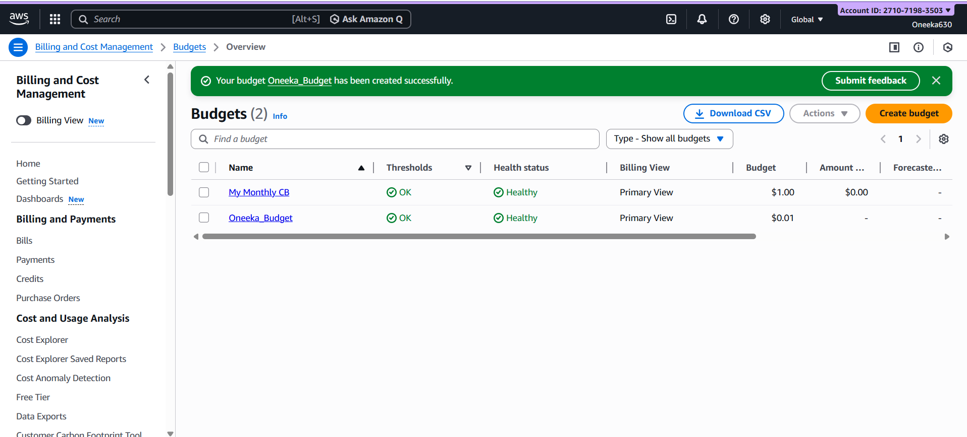

Budget Created!

